Ministry of Education and Science of Ukraine
National Technical University of Ukraine “Igor Sikorsky Kyiv Polytechnic Institute”
Educational and Scientific Institute of Atomic and Thermal Energy
Department of Digital Technologies in Energy

CALCULATION GRAPHICAL WORK
in the discipline “Visualisation of graphical and geometrical information”

Performed:
5th year student, IATE
Group TR-41mp
Zelinskyi V.Y
Variant 6

Checked by:
Docent Demchyshin A. A.

Kyiv – 2024
TASK

Operations on texture coordinates
Scale and rotate a texture around a user specified point.

Requirements:
- Reuse texture mapping from Control task.
- Implement texture scaling (texture coordinates) rotation around user specified point- odd variants implement scaling, even variants implement rotation
- It has to be possible to move the point along the surface (u,v) space using a keyboard. E.g. keys A and D move the point along u parameter and keys W and S move the point along v parameter.
Report
Prepare a digital report that holds:
- a title page;
- a chapter describing the task (1 page);
- a chapter describing theory (2 pages);
- a chapter describing the implementation details (2 pages);
- a chapter of user's instruction with screenshots (2 pages);
- a sample of source code (2 pages).

THEORY

Computer graphics is the generation of images based on mathematical and software algorithms. Shaders are an important element of modern graphics. They are used to customize the appearance of surfaces, lighting, and other visual effects.
Vertex shader. This is a program that runs for each vertex of an object. Its main task is to calculate the positions of vertices in space, the normal for lighting, and pass this information to the fragment shader.
Fragment shader. This shader processes each fragment (potential pixel) of the image. It is responsible for calculating color, texture, shadows, and other visual effects.
Lighting in computer graphics. Three lighting components are often used to create realistic objects:
- Ambient Lighting: Simulates diffuse light that illuminates all objects evenly.
- Diffuse Lighting: Takes into account the orientation of the surface relative to the light source to create a soft light effect.
- Specular Lighting: Creates a brilliance that depends on the angle between the direction of the light and the observer's gaze.
The Fong model combines these components to create realistic lighting.
Textures in shaders. Textures are two-dimensional images that are projected onto the surface of a three-dimensional object. The texture coordinates (UV coordinates) determine which part of the texture corresponds to a particular point on the object.
Implementation in HTML, JavaScript, and WebGL HTML. Used to create a canvas on which to render.
JavaScript. Controls program behavior, interactivity, keyboard event handling, and shader connection.
WebGL. Provides access to the graphics processing unit (GPU) for rendering 3D graphics.
Algorithm for moving and rotating points. Moving a texture point:
- The keys change the coordinates of a texture in the vertex array.
- The updated coordinates are passed to the WebGL buffer.
Rotate points:
The center of rotation is determined.
The new position of each point is calculated using the rotation formulas
$\left\{\begin{aligned}x^{'}=x*\cos\left(a\right)-y*\sin\left(a\right)+x_{o} \\ y^{'}=x*\sin\left(a\right)+y*\cos\left(a\right)+y_{o}\end{aligned}\right.$,
x,y the point to be spined,
x_{o},y_{o} – the center point,
a angle

Describing the implementation details

Added new changes. span to store point coordinates and rotation angle. Pressing wasd changes the position of the point, pressing q, e changes the rotation angle of the texture. The texture is rotated in the first shader so that the information is loaded without reloading the page. After calculating the texture coordinates, they are passed to varying and used in the pixel shader. The code is shown in Figure 1.
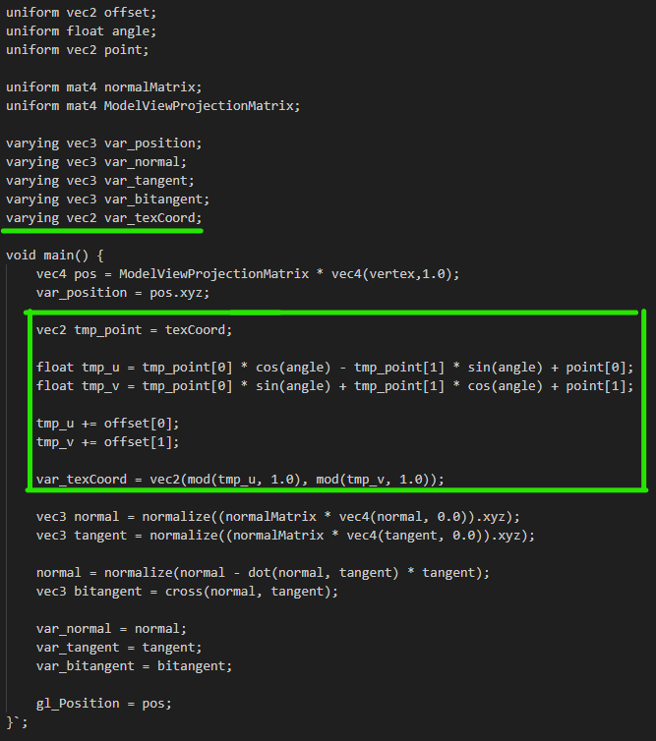
Figure 1- Vertex shader
User's instruction

Start figure
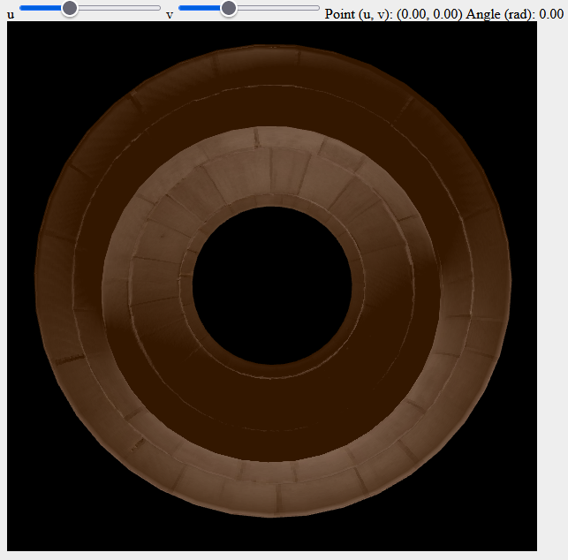
By pressing ‘A’ or ‘D’.
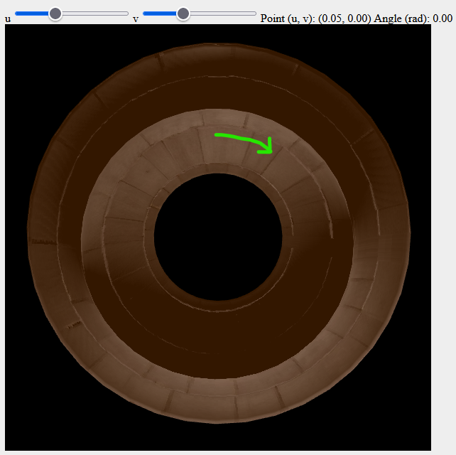
By pressing ‘W’, ‘S’
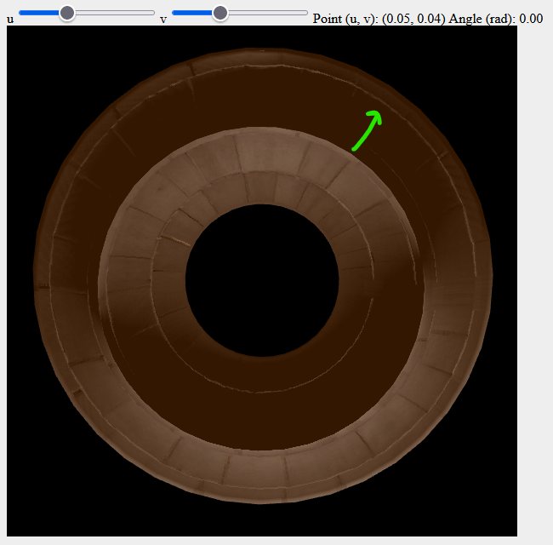
By pressing ‘Q’, ‘E’
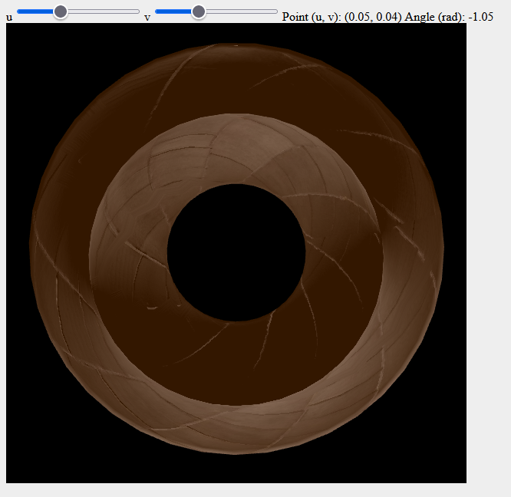

Sample of source code

// Vertex shader
const vertexShaderSource = `
attribute vec3 vertex;
attribute vec3 normal;
attribute vec2 texCoord;
attribute vec3 tangent;

uniform vec2 offset;
uniform float angle;
uniform vec2 point;

uniform mat4 normalMatrix;
uniform mat4 ModelViewProjectionMatrix;

varying vec3 var_position;
varying vec3 var_normal;
varying vec3 var_tangent;
varying vec3 var_bitangent;
varying vec2 var_texCoord;

void main() {
vec4 pos = ModelViewProjectionMatrix * vec4(vertex,1.0);
var_position = pos.xyz;

vec2 tmp_point = texCoord;

float tmp_u = tmp_point[0] * cos(angle) - tmp_point[1] * sin(angle) + point[0];
float tmp_v = tmp_point[0] * sin(angle) + tmp_point[1] * cos(angle) + point[1];

tmp_u += offset[0];
tmp_v += offset[1];

var_texCoord = vec2(mod(tmp_u, 1.0), mod(tmp_v, 1.0));

vec3 normal = normalize((normalMatrix * vec4(normal, 0.0)).xyz);
vec3 tangent = normalize((normalMatrix * vec4(tangent, 0.0)).xyz);

normal = normalize(normal - dot(normal, tangent) * tangent);
vec3 bitangent = cross(normal, tangent);

var_normal = normal;
var_tangent = tangent;
var_bitangent = bitangent;

gl_Position = pos;
}`;

// Fragment shader
const fragmentShaderSource = `
#ifdef GL_FRAGMENT_PRECISION_HIGH
precision highp float;
#else
precision mediump float;
#endif

varying vec3 var_position;
varying vec3 var_normal;
varying vec3 var_tangent;
varying vec3 var_bitangent;
varying vec2 var_texCoord;

uniform vec3 lightPos;
uniform sampler2D diffuseTexture;
uniform sampler2D specularTexture;
uniform sampler2D normalTexture;

void main() {
vec3 viewerPos = vec3(0.0, 0.0, 10.0);
vec3 ambient = vec3(0.2, 0.09, 0.0);

float shininess = 80.0;
float kA = 1.0;
float kD = 1.0;
float kS = 1.0;

vec3 textureNormal = texture2D(normalTexture, var_texCoord).xyz;
textureNormal = 2.0 * textureNormal - vec3(1.0, 1.0, 1.0);

mat3 TBN = mat3(var_tangent, var_bitangent, var_normal);
vec3 textureNormalTransf = normalize(TBN * textureNormal);

vec3 lightDir = normalize(lightPos - var_position);

float lambertian = max(dot(textureNormalTransf, lightDir), 0.0);
vec3 specular = vec3(0.0, 0.0, 0.0);
vec3 diffuse = vec3(0.0, 0.0, 0.0);
if (lambertian > 0.0){
diffuse = lambertian * texture2D(diffuseTexture, var_texCoord).rgb;

vec3 R = reflect(-lightDir, textureNormalTransf);
vec3 V = normalize(viewerPos - var_position);

float specAngle = max(dot(V, R), 0.0);
specular = pow(specAngle, shininess) * texture2D(specularTexture, var_texCoord).rgb;
}
gl_FragColor = vec4(kA * ambient +
kD * diffuse +
kS * specular, 1.0);
}`;

